**Forres Sandle Manor (Non-Academic) Policy**

|  |  |
| --- | --- |
| **Policy Title** | **Missing Child Policy** |
| **Policy Lead (Appointment (& Initials))** | **Deputy Head Pastoral (LM)** |
| **Date of last review** | **Oct 2024** |
| **Date of next Review** | **Oct 2025** |

**ACTION IN THE EVENT OF A CHILD BEING REPORTED AS MISSING**

**STAGE 1**

* Upon first awareness of child’s/children’s absence, staff member should
* Check SOCs to identify a possible timetable change. E.g music lesson or counselling session.
* Email ‘Teachers’ - Subject: Missing Child & child’s or children’s name and where they are expected to be.
* Verbally Contact:
* School Office (between hours of 8.30am – 5pm)
* Matrons - 5.00pm – 8.30am.
* School Office will verbally contact:
* Matrons
* LC
* Music Faculty
* Matrons will check:
* Activities
* Dormitories
* If child/children found – Teachers informed by email
* If child/children not found, alert SLT verbally and inform all teachers by email.
* **The time is to be noted as this is critical to the wider process**.

**STAGE 2**

* Senior member of staff (and others) to interview other children to ascertain details.
* SLT member to sound School Fire Alarm so all children assemble and a register can be taken. If missing pupils still not accounted for, remaining children return to class and;
* SLT member organises a search as shown below and issues the following:
  + Check all staff have their mobile phones
  + Copy of this instruction. Held in the Bursary
  + Marked Area Map and Control Net Diagram.

|  |  |  |  |  |  |
| --- | --- | --- | --- | --- | --- |
| **Area 1** | **Area 2** | **Area 3** | **Area 4** | **Area 5** | **Area 6** |
| Mews, Marchants, Science Lab, Blake’s Barn, Cabin Classroom, Lecky’s, Stable Building, Quad Block, Food Tech, CDT, Temp Science room, Pavilion, and all shrubbery & undergrowth in general area | Dudley-Hill Hall, Car park area, Music/IT Block & Pre-Prep | Main Building Ground Floor (including cellars) | Main Building 1st and 2nd Floors (including cupboards and under beds) | **5A**. Front of School and bushes, Top Moor area and woods, Storage Barn, Pond area, Ladies Drive to end.  **5B**. Pool, Front Terraces, Gardens, Bothy, Climbing frame & hard courts area, Woods adjacent to sports pitches, Main Drive and bordering undergrowth.  **5C**. Woods bordering sports pitches, Marl Lane, Old Railway Line. | By car down the drive. Turn right to old gates. Turn around.  Drive towards  Fordingbridge and left into Normandy Way. Into Marl Lane and return. |

* Report back to SLT member **WITHIN 15 MINUTES**.
* Then…SLT member of staff to telephone child’s home if within 5 miles.
* If the search remains unproductive, and ***after no more than 30 minutes of the suspicion first being reported***, alert the Police by dialling 999 with name, age, description, clothing and home address of the child together with details of whether parents are aware.
* SLT member of staff to organise mobile search parties as below and with reference to the child’s home address. Each car to carry a mobile phone:

|  |  |
| --- | --- |
| **Car 1** | Marl Lane, Puddleslosh Lane, Whitsbury to Fordingbridge Road. |
| **Car 2** | The drive, into Fordingbridge, right by Lambretta’s Italian Restaurant and out on the road to Alderholt, turning right down Ashford Lane to the railway pub and hotel. |
| **Car 3** | Down the drive, turn right to Sandleheath, right onto the Rockbourne Road. After pylons, turn right up track to forestry area. |

* Simultaneously, organise a second search of Areas 1 - 6 shown by the table on Page 1.
* If the child is a boarder and the search remains unproductive after a further 30 minutes, alert the parents.

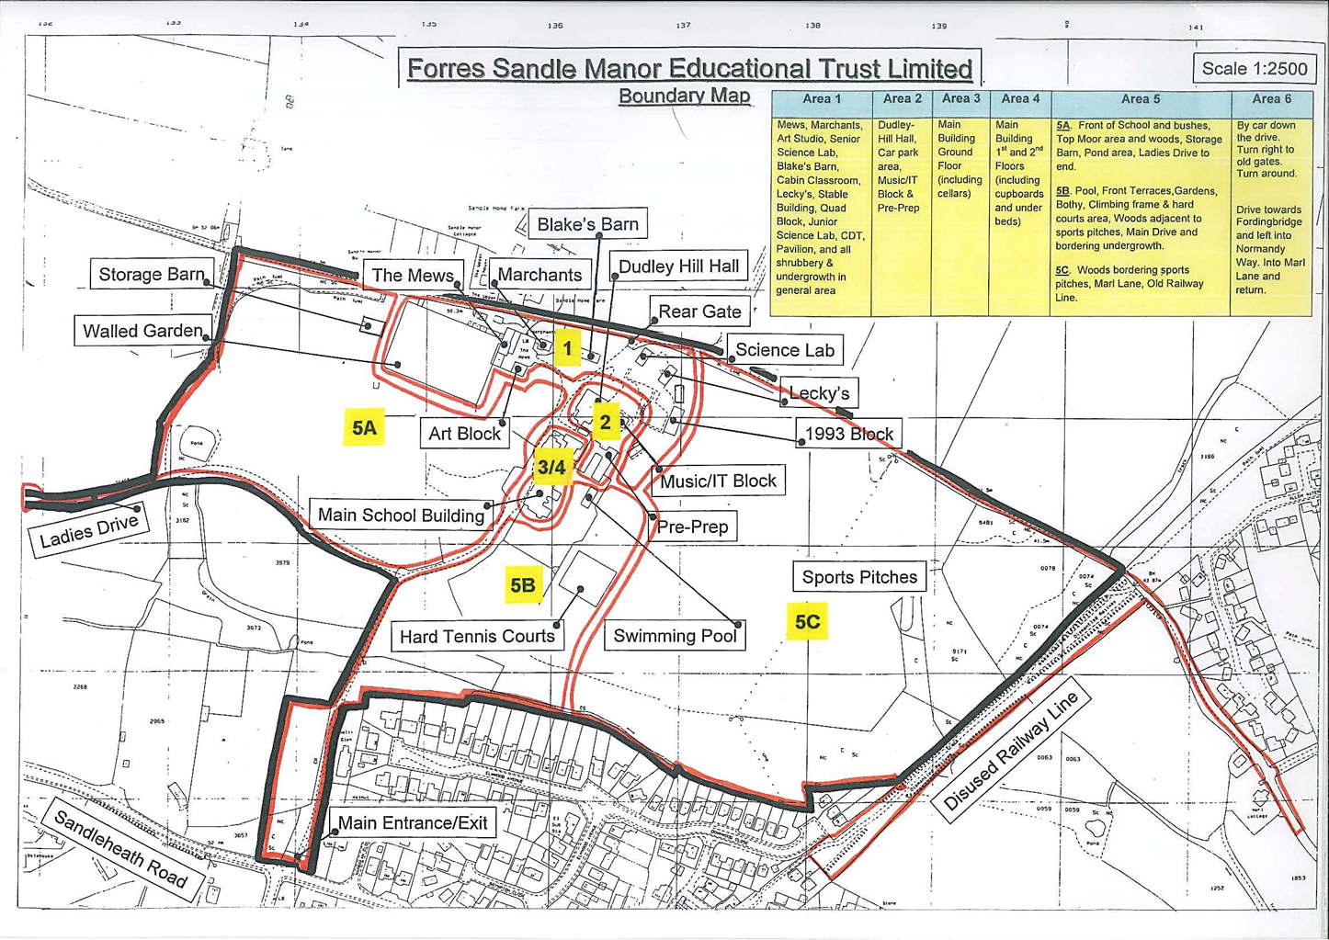

**Area 1** - Mews, Marchants, Science Lab, Blake’s Barn, Cabin Classroom, Lecky’s, Stable Building, Quad Block, Food Tech, CDT, Temp Science room, Pavilion, and all shrubbery & undergrowth in general area

**Area 2** - Dudley-Hill Hall, Car park area, Music/IT Block & Pre-Prep

**Area 3** - Main Building Ground Floor (including cellars)

**Area 4** - Main Building 1st and 2nd Floors (including cupboards and under beds)

**Area 5** - **5A**. Front of School and bushes, Top Moor area and woods, Storage Barn, Pond area, Ladies Drive to end. **5B**. Pool, Front Terraces, Gardens, Bothy, Climbing frame & hard courts area, Woods adjacent to sports pitches, Main Drive and bordering undergrowth. **5C**. Woods bordering sports pitches, Marl Lane, Old Railway Line.

**Area 6** - By car down the drive. Turn right to old gates. Turn around. Drive towards Fordingbridge and left into Normandy Way. Into Marl Lane and return.